B.H. COLLEGE
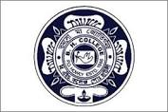
HOWLY:: BARPETA::ASSAM
DEPARTMENT: Education | DATE: 20-11-2022
No. of Students/Participants | 62
Title of the Programme
Interaction cum motivational speech
Name of the Speaker
Amir Hussain, AES, Govt. of Assam
Dr. Bhanu Nath Talukdar
Ex- Vice- Principal
B.H. College, Howly

Description of the Programme
An interaction and Motivational Programme was held on 20-11-2022 at Auditorium of B.H. College. The speaker discussed with the students about career and Discipline. Teachers and students participated actively in the programme.

